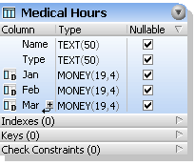

Medical hours – displays the billable hours for each physician by month. Needs to be changed into a stored procedure that will be displayed in a report. :

Name – Care Provider name.
Type - Type of provider (doctor, clinician, etc).
Jan – January total billable hours.
Feb – February total billable hours.
Mar – March total billable hours

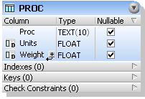

Proc - ?

Proc:
BV - ?
CV - ?
RV - ?
FVWP - ?
FVOP - ?
GV - ?
ML - ?
PAS - ?
PM - ?
PE - ?
NS - ?
C - ?
PASNS - ?
SC - ?
PASC - ?
Units - ?
Weight - ?

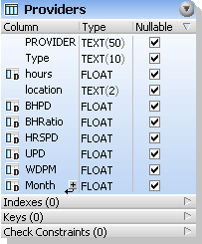

Providers – Gives a listing of the providers, and calculates the number of hours they have worked vs the number of hours they should have worked, and shows how much money they have generated. Probably change this to a view.

Provider - name of provider
Type - type of provider (doctor, clinician, etc.)
hours - total hours per work.
location - Utica, rome, etc.
BHPD - Billable hours per day.
BHRatio – Billable Hours Ratio
HRSPD - Hours Per Day – billable hours per day?
UPD - ?
WDPM - ?
Month – which month

Providers2 - same as providers table, have to determine which is the correct table to use.

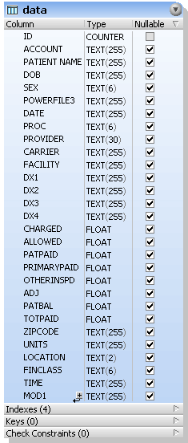

Data – data that is dumped from the pervasive database.

Id – key field not important
Account - user account #
Patient Name - patient name
Dob - date of birth
Sex - male or female
Powerfile3 - comes up as “E”, not sure what this means ?
Date - date patient visited.
Proc - procedure that we provided patient
Provider – doctor, clinician etc.
Carrier - insurance
Facility – Utica or Rome
Dx1 - looks like charge for visit
Dx2 - blank field, should it be filled ?
Dx3 - blank field, should it be filled ?
Dx4 - blank field, should it be filled ?
Charged - whether client was charged or not.
Allowed - blank
Patpaid - blank
Primarypaid - blank
Otherinspd - blank
Adj - blank
Patbal - blank
Totpaid - blank
Zipcode - patient zip
Units - visits?
Location - Utica or Rome
Finclass - Fin Class? There are 23 different values (AP, BC, BH, CM, CO, CP, HO, MC,MD, MM, MV, NA, SA, SB, SC, SG, SI, SJ, SL, SP, UH, UN, VS, Time, Mod1) Would you know what each of these means?

